
Progression skills in Design Technology
Sir Francis Hill Primary School
 | Year 1 | Year 2 | Year 3 | Year 4 | Year 5 | Year 6
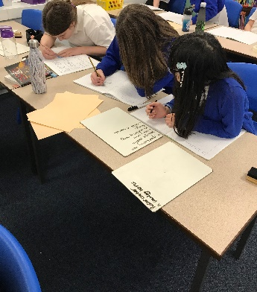  Developing, planning and communicating ideas | Begin to draw on their own experience to help generate ideas and research conducted on criteria.  Begin to understand the development of existing products: What they are for, how they work, materials used. Start to suggest ideas and explain what they are going to do.  Understand how to identify a target group for what they intend to design and make based on a design criteria.  Begin to develop their ideas through talk and drawings. Make templates and mock ups of their ideas in card and paper or using ICT. | Start to generate ideas by drawing on their own and other people's experiences. Begin to develop their design ideas through discussion, observation, drawing and modelling.  Identify a purpose for what they intend to design and make.  Understand how to identify a target group for what they intend to design and make based on a design criteria.  Develop their ideas through talk and drawings and label parts. Make templates and mock ups of their ideas in card and paper or using ICT. | With growing confidence generate ideas for an item, considering its purpose and the user/s.  Start to order the main stages of making a product. Identify a purpose and establish criteria for a successful product.  Understand how well products have been designed, made, what materials have been used and the construction technique.  Know to make drawings with labels when designing. When planning explain their choice of materials and components including function and aesthetics.  Start to understand whether products can be recycled or reused.  Learn about inventors, designers, engineers, chefs and manufacturers who have developed ground-breaking products. | Start to generate ideas, considering the purposes for which they are designing- link with Mathematics and Science.  When planning explain their choice of materials and components according to function and aesthetic.  Confidently make labelled drawings from different views showing specific features.  Develop a clear idea of what has to be done, planning how to use materials, equipment and processes, and suggesting alternative methods of making, if the first attempts fail. Identify the strengths and areas for development in their ideas and products. When planning consider the views of others, including intended users, to improve their work.  Learn about inventors, designers, engineers, chefs and manufacturers who have developed ground -breaking products. | Start to generate, develop, model and communicate their ideas through discussion, annotated sketches, cross-sectional and exploded diagrams, prototypes, pattern pieces.  Begin to use research and develop design criteria to inform the design of innovative, functional, appealing products that are fit for purpose.  Draw up a specification for their design- link with Mathematics and Science.  Use results of investigations, information sources, including ICT when developing design ideas.  With growing confidence apply a range of finishing techniques, including those from art and design.  With growing confidence select appropriate materials, tools and techniques.  Start to understand how much products cost to make, how sustainable and innovative they are and the impact products have beyond their intended purpose. | Generate, develop, model and communicate their ideas through discussion, annotated sketches, cross-sectional and exploded diagrams, prototypes, pattern pieces.  Use research and develop design criteria to inform the design of innovative, functional, appealing products that are fit for purpose.  Draw up a specification for their design- link with Mathematics and Science.  Plan the order of their work, choosing appropriate materials, tools and techniques.  Accurately apply a range of finishing techniques, including those from art and design.  Suggest alternative methods of making if the first attempts fail.  Identify the strengths and areas for development in their ideas and products.  Know how much products cost to make, how sustainable and innovative they are and the impact products have beyond their intended purpose.

 | Year 1 | Year 2 | Year 3 | Year 4 | Year 5 | Year 6
Working with tools, equipment, materials and components to make quality products  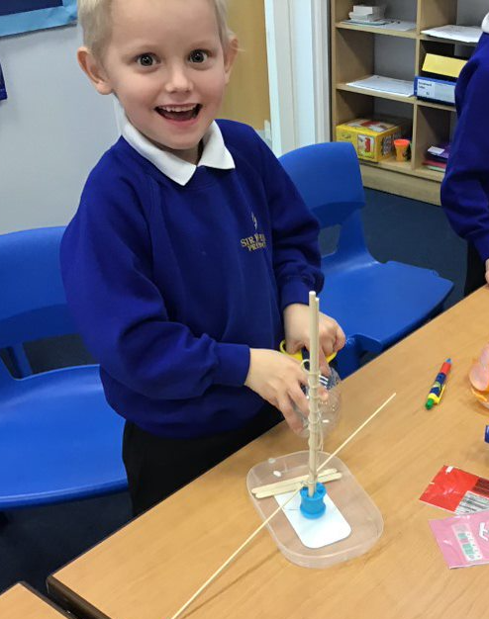 | Begin to make their design using appropriate techniques.  Begin to build structures, exploring how they can be made stronger, stiffer and more stable.  With help measure, mark out, cut and shape a range of materials. Explore using tools e.g. scissors and a hole punch safely.  Begin to assemble, join and combine materials and components together using a variety of temporary methods e.g. glues or masking tape. Begin to use simple finishing techniques to improve the appearance of their product.  Explore and use mechanisms [for example, levers, sliders, wheels and axles], in their products. | Begin to select tools and materials; use correct vocabulary to name and describe them.  Build structures, exploring how they can be made stronger, stiffer and more stable.  With help measure, cut and score with some accuracy. Learn to use hand tools safely and appropriately.  Start to assemble, join and combine materials in order to make a product. Start to choose and use appropriate finishing techniques based on own ideas.  Demonstrate how to cut, shape and join fabric to make a simple product. Use basic sewing techniques. | Select a wider range of tools and techniques for making their product i.e. construction materials and kits, textiles, food ingredients, mechanical components and electrical components.  Explain their choice of tools and equipment in relation to the skills and techniques they will be using. Start to work safely and accurately with a range of simple tools. Measure, mark out, cut, score and assemble components with more accuracy.  Start to think about their ideas as they make progress and be willing to change things if this helps them to improve their work.  Start to understand that mechanical and electrical systems have an input, process and output. Start to understand that mechanical systems such as levers and linkages or pneumatic systems create movement.  Know how simple electrical circuits and components can be used to create functional products.  Start to measure, tape or pin, cut and join fabric with some accuracy. | Select a wider range of tools and techniques for making their product safely.  Know how to measure, mark out, cut and shape a range of materials, using appropriate tools, equipment and techniques. Start to join and combine materials and components accurately in temporary and permanent ways.  Continue to learn how to program a computer to monitor changes in the environment and control their products. Begin to use finishing techniques to strengthen and improve the appearance of their product using a range of equipment including ICT.  Understand how to reinforce and strengthen a 3D framework.  Know how mechanical systems such as cams or pulleys or gears create movement.  Understand how more complex electrical circuits and components can be used to create functional products.  Now sew using a range of different stitches, to weave and knit.  Demonstrate how to measure, tape or pin, cut and join fabric with some accuracy. | Select appropriate materials, tools and techniques e.g. cutting, shaping, joining and finishing, accurately.  Select from and use a wider range of materials and components, including construction materials, textiles and ingredients, according to their functional properties and aesthetic qualities.  Demonstrate how to use skills in using different tools and equipment safely and accurately with growing confidence cut and join with accuracy to ensure a good-quality finish to the product.  Weigh and measure accurately (time, dry ingredients, liquids).  Understand how mechanical systems such as cams or pulleys or gears create movement.  Know how more complex electrical circuits and components can be used to create functional products and how to program a computer to monitor changes in the environment and control their products. Understand that mechanical and electrical systems have an input, process and output. Begin to measure and mark out more accurately.  Use finishing techniques to strengthen and improve the appearance of their product using a range of equipment including ICT. | Confidently select appropriate tools, materials, components and techniques and use them. Aim to make and to achieve a quality product.  Use tools safely and accurately.  Assemble components to make working models. Construct products using permanent joining techniques.  Demonstrate when make modifications as they go along.  Know how to reinforce and strengthen a 3D framework. Use finishing techniques to strengthen and improve the appearance of their product using a range of equipment including ICT.  Understand how mechanical systems such as cams or pulleys or gears create movement.  Know how more complex electrical circuits and components can be used to create functional products and how to program a computer to monitor changes in the environment and control their products.  Understand that mechanical and electrical systems have an input, process and output.  With confidence pin, sew and stitch materials together to create a product.
 | Year 1 | Year 2 | Year 3 | Year 4 | Year 5 | Year 6
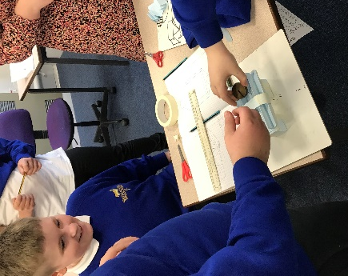  Evaluating processes and products | Start to evaluate their product by discussing how well it works in relation to the purpose (design criteria).  When looking at existing products explain what they like and dislike about products and why.  Begin to evaluate their products as they are developed, identifying strengths and possible changes they might make | Evaluate their work against their design criteria.  Look at a range of existing products explain what they like and dislike about products and why. With confidence talk about their ideas, saying what they like and dislike about them.  Start to evaluate their products as they are developed, identifying strengths and possible changes they might make. | Start to evaluate their product against original design criteria e.g. how well it meets its intended purpose.  Begin to disassemble and evaluate familiar products and consider the views of others to improve them.  Evaluate the key designs of individuals in design and explain how technology has helped shape the world. | Evaluate their products carrying out appropriate tests. Start to evaluate their work both during and at the end of the assignment.  Be able to disassemble and evaluate familiar products and consider the views of others to improve them.  Evaluate the key designs of individuals in design and explain how technology has helped shape the world. | Start to evaluate a product against the original design specification and by carrying out tests.  Evaluate their work both during and at the end of the assignment. Begin to evaluate it personally and seek evaluation from others.  Evaluate the key designs of individuals in design and explain how technology has helped shape the world. | Evaluate their products, identifying strengths and areas for development, and carrying out appropriate tests. Evaluate their work both during and at the end of the assignment.  Record their evaluations using drawings with labels. Evaluate against their original criteria and suggest ways that their product could be improved.  Evaluate the key designs of individuals in design and explain how technology has helped shape the world.
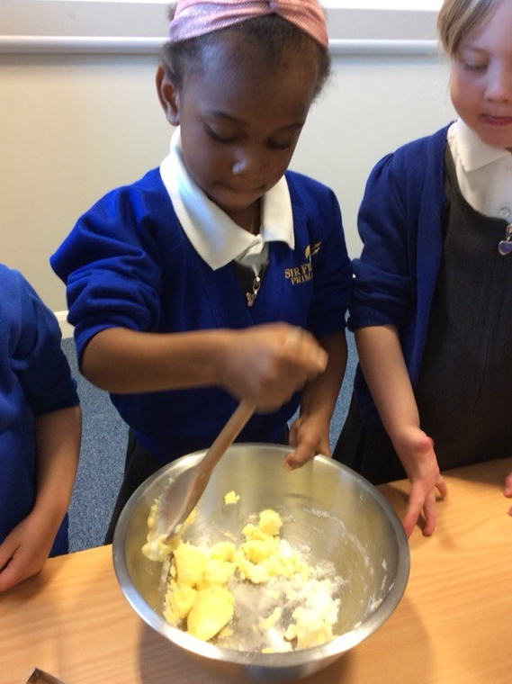  Food Nutrition | Begin to understand that all food comes from plants or animals. Explore the understanding that food has to be farmed, grown elsewhere (e.g. home) or caught.  Start to understand how to name and sort foods into the five groups in ‘The Eat well plate’.  Begin to understand that everyone should eat at least five portions of fruit and vegetables every day.  Know how to prepare simple dishes safely and hygienically, without using a heat source.  Know how to use techniques such as cutting, peeling and grating. | Understand that all food comes from plants or animals. Know that food has to be farmed, grown elsewhere (e.g. home) or caught.  Understand how to name and sort foods into the five groups in ‘The Eat well plate’. Know that everyone should eat at least five portions of fruit and vegetables every day.  Demonstrate how to prepare simple dishes safely and hygienically, without using a heat source.  Demonstrate how to use techniques such as cutting, peeling and grating. | Start to know that food is grown (such as tomatoes, wheat and potatoes), reared (such as pigs, chickens and cattle) and caught (such as fish) in the UK, Europe and the wider world.  Start to understand that a healthy diet is made up from a variety and balance of different food and drink, as depicted in ‘The Eat well plate’. Begin to know that to be active and healthy, food and drink are needed to provide energy for the body.  Understand how to prepare and cook a variety of predominantly savoury dishes safely and hygienically including, where appropriate, the use of a heat source.  Begin to understand how to use a range of techniques such as peeling, chopping, slicing, grating, mixing, spreading, kneading and baking. | Understand that food is grown (such as tomatoes, wheat and potatoes), reared (such as pigs, chickens and cattle) and caught (such as fish) in the UK, Europe and the wider world.  Know that a healthy diet is made up from a variety and balance of different food and drink, as depicted in ‘The Eat well plate’. Know that to be active and healthy, food and drink are needed to provide energy for the body.  Understand how to prepare and cook a variety of predominantly savoury dishes safely and hygienically including, where appropriate, the use of a heat source.  Know how to use a range of techniques such as peeling, chopping, slicing, grating, mixing, spreading, kneading and baking. | Understand that food is grown (such as tomatoes, wheat and potatoes), reared (such as pigs, chickens and cattle) and caught (such as fish) in the UK, Europe and the wider world. Begin to understand that seasons may affect the food available. Understand how food is processed into ingredients that can be eaten or used in cooking.  Begin to understand that different food and drink contain different substances – nutrients, water and fibre – that are needed for health.  Know how to prepare and cook a variety of predominantly savoury dishes safely and hygienically including, where appropriate, the use of a heat source.  Start to understand how to use a wider range of techniques such as peeling, chopping, slicing, grating, mixing, spreading, kneading and baking. | Know that food is grown (such as tomatoes, wheat and potatoes), reared (such as pigs, chickens and cattle) and caught (such as fish) in the UK, Europe and the wider world. Understand that seasons may affect the food available. Understand how food is processed into ingredients that can be eaten or used in cooking.  Know different food and drink contain different substances – nutrients, water and fibre – that are needed for health.  Know how to prepare and cook a variety of predominantly savoury dishes safely and hygienically including, where appropriate, the use of a heat source.  Understand how to use a range of techniques such as peeling, chopping, slicing, grating, mixing, spreading, kneading and baking.

