Names: ________________________________________________________ Date: ___________________________
L.O: To understand the Christian Festival of Pentecost
Imagine that you could suddenly speak any language you wanted? How would you feel? Why?  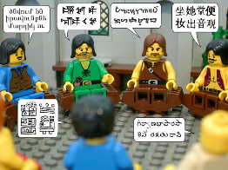 | Imagine that you were stood in the crowd on Pentecost.  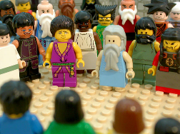
IF YOU COULD HAVE ANY SUPERPOWER...WHAT WOULD IT BE? WHY?  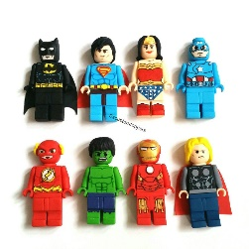 | What can you remember about the story of Pentecost?

