Visual Timetables

Visual timetables offer a solid visual representation of the day ahead or tasks to be completed. They are unique to every child based on their needs, age and interests. You can create one for your child or encourage them to create one with you. They can be as simple or creative as you like as long as they are clear and easy to understand. Use pictures for younger children or if you feel your child would respond better to images. You might want to include things that may motivate your child – maybe a Spiderman or a dinosaur themed one would work well.

8.30 | 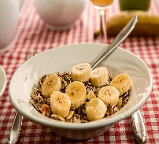 | Breakfast
9.00 |  | Get washed, clean your teeth and get dressed
9.30 | 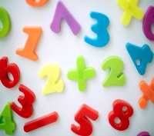 | Maths work sent from school
10.00 |  | Play in the garden  Have a snack
10.30 | 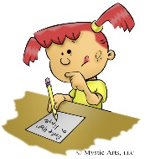 | Writing and spelling tasks sent from school
11:30 |  | Story time with mum

Children could also have choices offered to them in a visual way. Maybe a menu on the table at meal times or a choice of play activity for the afternoon. These could include pictures of their options or a simple list.
( 3 choices are best )

Lego | Play dough | Cars
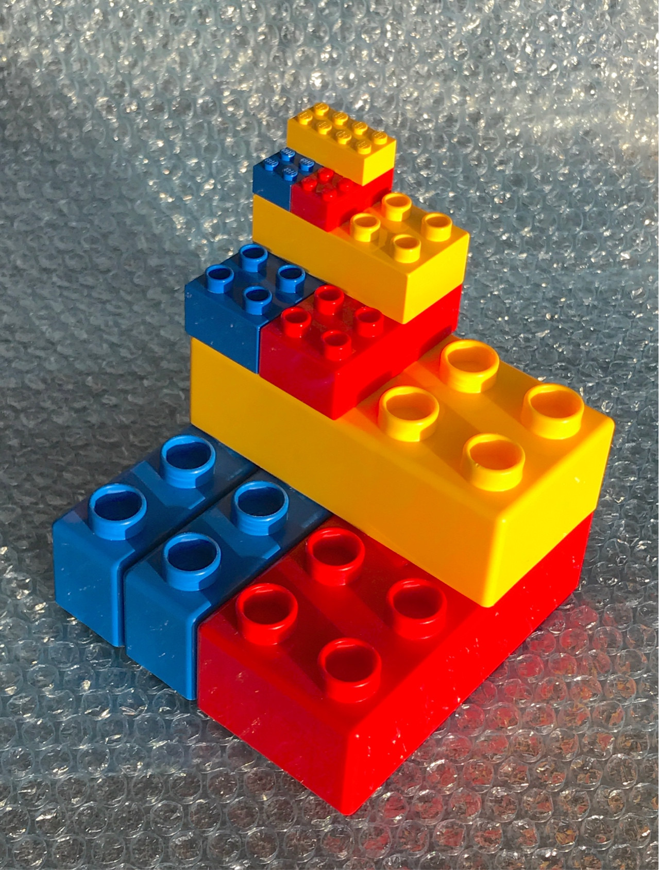 | 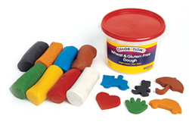 | 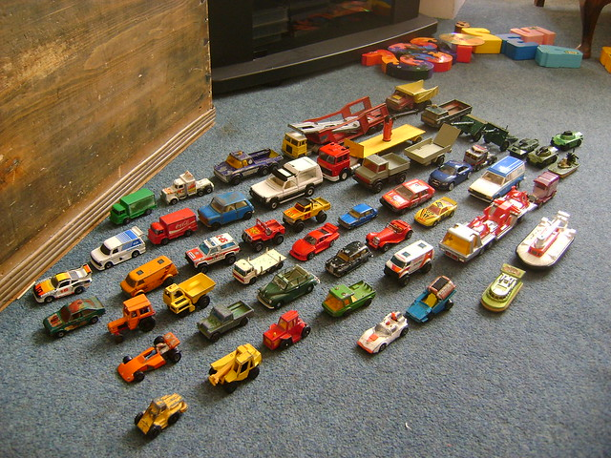

Autistic children thrive if they are offered a predictable schedule. Visual timetables are an excellent way to provide a consistent and structured approach to daily routines and challenges.

[Cite your source here.]

Today the Breakfast choices are:
- Toast
- Cornflakes
- Pancakes

For some children a simple now/next visual board might work well.

Now | 
Next | 

