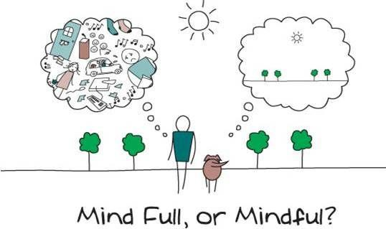
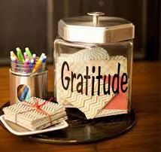

Follow the link to listen to the Peace Out podcast.
https://bedtime.fm/pea ceout
Create a gratitude jar. Each day, write something you are grateful for and pop it in the jar!
Be kind to yourself yyyourself

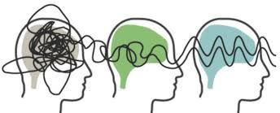Wellbeing Activities to Choose From:
In times like these, our mental and physical wellbeing is…
The most important thing!
Use this wellbeing menu to choose a fun and relaxing activity each day, which will help to keep you mindful and healthy.
Keeping active and giving yourself time to relax and reﬂect on how you are feeling, will help you to be mindful and healthy.

Koo Koo Kanga Roo
Zumba Kids
Think about it
Flow
https://family.gonoodle.com
Be mindful, sing, dance or meditate on GoNoodle. I would
recommend checking out the following channels:

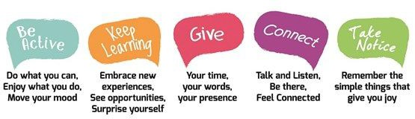



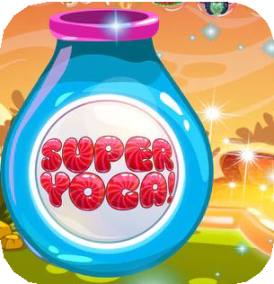

More Wellbeing Activities to Choose From:
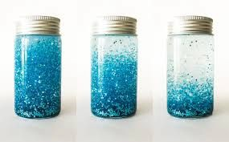
Listen to relaxing stories and guided meditations based on much loved characters. https://www.honeybeekid sclub.com/
Complete a ﬁnger breathing exercise. Calmly breathe in and out, as you trace up and down your ﬁngers.
Tune in to this TimeOut recommended podcast - ‘WOW in the World’. Listen to American hosts, Mindy Thomas and Guy Raz, answer curious kids’ questions. Join them on a journey to discover the wonders of the world around us and learn something new.
https://www.npr.org/podcasts/510321/wow-in-the-world

Subscribe to Cosmic Kids Yoga Channel - What will you try?

Will choose a yoga adventure - a story told through yoga poses? Perhaps you will get active with Harry Potter yoga or Moana, Frozen, Star Wars or Trolls?!

Will you take part in a Zen Den activity, where you can get some calm in your day? Here, you can learn about your feelings, practise breathing techniques to reduce stress and become a happier more present human being.
Will you play a fun and exciting game of Super Yoga where you have to do yoga poses to earn points and complete the game.
https://www.youtube.com/user/CosmicKidsYoga
Additional Links and Ideas
Using pinwheels or blowing bubbles slowly, to practice controlled breathing
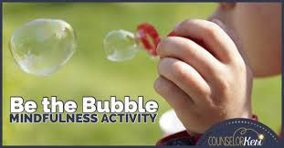
https://www.mindful. org/how-to-create-a- glitter-jar-for-kids/

https://www.headsp ace.com/

